100071011 Computer Networks 2023-2024-2
Project-1
Reliable File Transfer using Go-Back-N protocol
Specification

学号 (Student ID) | 1820221053
姓名 (Name) | 曾泇睷
班号 (Class No.) | 07812201
授课教师 (Instructor) | 胡琳梅 教师

School of Computer
Beijing Institute of Technology
April 12, 2024

- Requirement Analysis
The project aims to implement a reliable file transfer system over UDP using the Go-Back-N (GBN) protocol. The system must ensure reliable data transfer despite potential packet losses and errors, simulating real-world network conditions.

Key requirements include:
• Reliable Transfer: Use GBN to handle packet losses and errors, ensuring the receiver gets an exact copy of the sender’s file.
• UDP Sockets: Implement communication using UDP, which is unreliable, requiring GBN for reliability.
• Full-Duplex Communication: Both hosts act as sender and receiver simul-tenuously, transferring a 3 MB file.
• Configuration File: Read parameters (e.g., ports, timeout, error/loss rates) from a configuration file.
• Logging: Record detailed communication states for each PDU sent/received in a specified format.
• Performance Analysis: Compute metrics like throughput, retransmissions, and duration.

Main Issues include:
• Managing the sliding window mechanism in GBN.
• Handling timeouts and retransmissions effectively.
• Ensuring data integrity through checksums.
• Synchronizing sender and receiver in full-duplex mode.

- Design
  - Frame Structure
The Protocol Data Unit (PDU) structure includes:
• type: 0 (data), 1 (ACK), 2 (last data).
• seqNum: 32-bit sequence number for data or ACK number.
• checksum: CRC-CCITT for error detection.
• data: Payload, up to 4KB.

  - Checksum Generation and Checking
The CRC-CCITT algorithm is employed to generate and verify checksums, ensuring data integrity.

  - Sliding Windows
The sender uses a configurable window size N, while the receiver expects PDUs in sequence, discarding out-of-order packets as per GBN.

  - Buffering
The sender buffers PDUs within the window, and the receiver may buffer out-of-order PDUs, though GBN typically discards them.

  - Sequence Spaces and Numbers
Sequence numbers are 32-bit integers, providing a large sequence space to avoid wraparound issues.

  - Acknowledgment Rules
Cumulative ACKs are used, where an ACK for sequence number k confirms receipt of all PDUs up to k.

  - Retransmissions
Upon timeout, the sender retransmits all PDUs in the window starting from the oldest unacknowledged PDU.

  - Timeout
Timer A single timer tracks the oldest unacknowledged PDU.

  - UDP Socket
UDP sockets facilitate PDU transmission and reception.

  - System Model
Each host runs two threads: one for sending and one for receiving, enabling full-duplex communication.

  - Functions/Classes
• PDU struct: Defines the PDU structure.
• Logger class: Handles asynchronous logging.
• sender and receiver functions: Implement core logic.

  - Flow Charts, State Diagrams, and Time-Sequence Diagrams
• Sender Flow: Send PDUs within window, process ACKs, handle timeouts.
• Receiver Flow: Receive PDUs, verify checksums, send ACKs.
• States: Sender (Idle, Sending, Waiting for ACK); Receiver (Waiting for PDU, Sending ACK).
• Time-Sequence: Normal operation and error scenarios (e.g., PDU loss).

  - Error Simulations
Random PDU errors and losses are simulated based on configurable rates.

  - Logging
Asynchronous logging minimizes performance overhead.

  - Configuration File
Parameters include ports, data size, window size, timeout, error/loss rates, and file names.

  - Multi-Threading
Separate threads manage sending and receiving tasks.

  - Initialization
The system reads parameters from a configuration file during startup.

- Development and Implementation
  - Development Tools
• OS: Windows
• Language: C++
• Libraries: Winsock2

  - Project Structure
• pdu.h: PDU structure and functions.
• utils.h: Configuration and logging utilities.
• sender.cpp: Sender implementation.
• receiver.cpp: Receiver implementation.
• main.cpp: Program entry point.

  - Critical Functions
• calculateCRC: Computes CRC-CCITT checksum.
• serializePDU / deserializePDU: PDU serialization and deserialization.
• Logger class: Manages asynchronous logging.

  - Sample Code
The following code snippets highlight key functionalities of the system:

    - PDU Serialization
This function converts a PDU structure into a byte stream for UDP transmission, handling both data and ACK PDUs.

std::vector<char> serializePDU(const PDU& pdu, size_t dataSize) {
size_t totalSize = (pdu.type == TYPE_ACK) ? 7 : (7 + dataSize);
std::vector<char> buffer(totalSize);
buffer[0] = pdu.type;
memcpy(&buffer[1], &pdu.seqNum, sizeof(pdu.seqNum));
memcpy(&buffer[5], &pdu.checksum, sizeof(pdu.checksum));
if (pdu.type == TYPE_DATA || pdu.type == TYPE_LAST_DATA) {
memcpy(&buffer[7], pdu.data, dataSize);
}
return buffer;
}

    - Checksum Calculation
The CRC-CCITT algorithm ensures data integrity by generating a checksum for each PDU.

uint16_t calculateCRC(const char* data, size_t length) {
const uint16_t POLYNOMIAL = 0x1021;
uint16_t crc = 0xFFFF;
for (size_t i = 0; i < length; ++i) {
crc ^= (static_cast<uint16_t>(data[i]) << 8);
for (int j = 0; j < 8; ++j) {
if (crc & 0x8000) {
crc = (crc << 1) ^ POLYNOMIAL;
} else {
crc <<= 1;
}
}
}
return crc;
}

    - Sender Logic (Window Management)
This excerpt from the sender function illustrates the sliding window mechanism, including PDU transmission and timeout handling

while (nextSeqNum < base + config.windowSize && nextSeqNum < stats.totalPDUs) {
PDU& pdu = pdus[nextSeqNum];
bool shouldSend = dis(gen) >= config.lossRate;
if (shouldSend) {
PDU sendPdu = pdu;
if (dis(gen) < config.errorRate) {
sendPdu.data[0] ^= 0x01; // Flip a bit to simulate error
}
std::vector<char> buffer = serializePDU(sendPdu, config.dataSize);
sendto(sock, buffer.data(), buffer.size(), 0, (sockaddr*)&remoteAddr, sizeof(remoteAddr));
std::string status = (nextSeqNum >= base) ? "New" : "TO";
stats.totalSends++;
if (status == "TO") stats.retransmitCount++;
Logger logger("transfer.log");
logger.log(std::to_string(sendCount++) + ", pdu_to_send=" + std::to_string(nextSeqNum) + ", status=" + status + ", ackedNo=" + std::to_string(base));
}
if (base == nextSeqNum) {
sendTimes[nextSeqNum] = std::chrono::steady_clock::now();
timerRunning = true;
}
nextSeqNum++;
}

    - Asynchronous Logging
The Logger class reduces file I/O overhead by buffering log messages and writing them in batches.

class Logger {
public:
Logger(const std::string& logFileName) : logFile(logFileName, std::ios::app), running(true) {
if (!logFile) {
throw std::runtime_error("Cannot open log file");
}
loggingThread = std::thread(&Logger::loggingFunction, this);
}

~Logger() {
stop();
}

void log(const std::string& message) {
{
std::lock_guard<std::mutex> lock(queueMutex);
logQueue.push(message);
}
cv.notify_one();
}

void stop() {
{
std::lock_guard<std::mutex> lock(queueMutex);
running = false;
}
cv.notify_one();
if (loggingThread.joinable()) {
loggingThread.join();
}
}

private:
std::ofstream logFile;
std::queue<std::string> logQueue;
std::mutex queueMutex;
std::condition_variable cv;
std::thread loggingThread;
bool running;

void loggingFunction() {
while (running || !logQueue.empty()) {
std::vector<std::string> batch;
{
std::unique_lock<std::mutex> lock(queueMutex);
cv.wait(lock, [this]{ return !logQueue.empty() || !running; });
while (!logQueue.empty()) {
batch.push_back(logQueue.front());
logQueue.pop();
}
}
for (const auto& msg : batch) {
logFile << msg << std::endl;
}
logFile.flush(); // Ensure logs are written immediately
}
}
};

- System Deployment, Startup, and Use
  - Deployment
Compile the code using Visual Studio or the cl compiler. Prepare configuration files for each host.

  - Startup
Run the executable with a configuration file, e.g., FileTransfer.exe config1.txt.

  - Use
The system automatically initiates file sending and receiving based on the configuration.

- System Test
  - Unit Test
• Tested PDU serialization and deserialization.
• Verified checksum calculation and validation.

  - Integrated Test
• Tested file transfer with varying error/loss rates.
• Confirmed received files match originals.

  - Test Cases
• Normal transfer without errors.
• Transfer with simulated errors.
• Transfer with simulated losses.

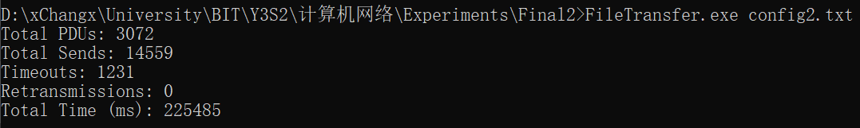
  - Screenshots

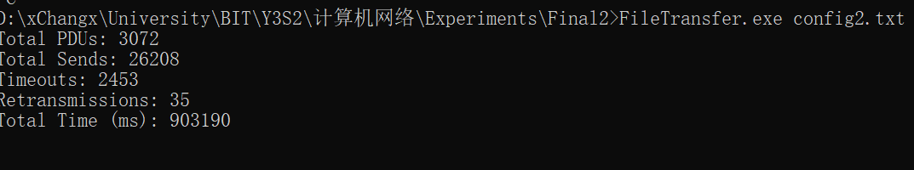

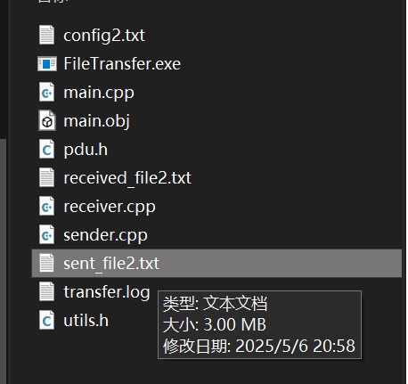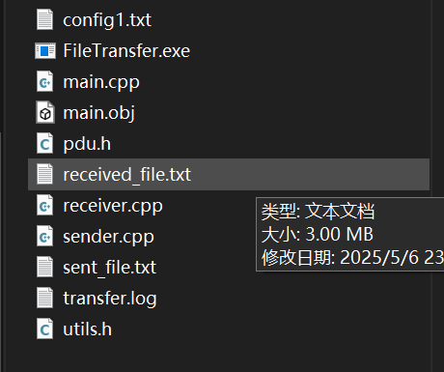
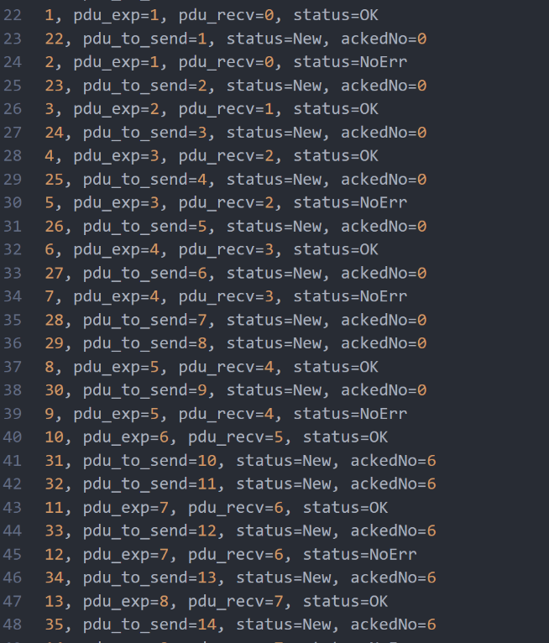

- Performance and Analysis
  - Performance Metrics
• Total PDUs sent.
• Total send attempts.
• Number of timeouts.
• Number of retransmissions.
• Total transfer time.

  - Analysis
Performance was evaluated by varying data size, window size, error/loss rates, and timeout values. Metrics were plotted to assess their impact.

  - Data Sheet
Config | Data Size | Window Size | Error Rate | Loss Rate | Time (s)
1 | 3 MB | 5 | 0.03 | 0.03 | 903.19
2 | 3MB | 10 | 0.05 | 0.05 | 206.66
Table 1: Performance metrics under different configurations.

- Summary or Conclusions
This project provided hands-on experience with the GBN protocol, resulting in a reliable file transfer system. Challenges included managing sliding windows, handling timeouts, and ensuring data integrity with checksums. The technical solution involved UDP sockets, multi-threading, and CRC-CCITT checksums. The system successfully achieved reliable transfers despite simulated errors and losses, with key features such as full-duplex communication, configurable parameters, and detailed logging.

- References
[1] Computer networks / Andrew S. Tanenbaum, David J. Wetherall. -- 5th ed.
[2] UDP Communication. https://wiki.python.org/moin/UdpCommunication
[3] An Intro to Threading in Python . https://realpython.com/intro-to-python-threading/
[4] recv and recvfrom, socket programming using python. https://stackoverflow.com/questions/36115971/recv-and-recvfrom-socket-programming-using-python
[5] Go-Back-N Protocol. https://www.baeldung.com/cs/networking-go-back-n-protocol

- Comments
This project proved to be an intensive learning journey that challenged me both intellectually and physically. Initially overwhelmed by the complexity of implementing network protocols from scratch, I dedicated two consecutive sleepless nights to research, coding, and iterative debugging. Through systematic study of technical documentation and persistent experimentation, I gradually conquered each technical hurdle. While the process demanded extraordinary effort, it profoundly deepened my comprehension of computer network architectures and significantly enhanced my software engineering capabilities. The hands-on experience with protocol design and error simulation proved invaluable, transforming theoretical textbook concepts into practical engineering wisdom.

